KCH5N -

Functionality
The standard hierarchy is a tree structure that contains all profit centers in a controlling area and reflects the organizational structure used in Profit Center Accounting.

Scenario
Exploring this transaction in order to move a Profit Center from one Group to Another

Requirements
A Standard hierarchy should exist.

Menu Path | Accounting → Controlling → Profit Center Accounting → Master Data → Standard Hierarchy → KCH5N - Change
Transaction Code | KCH5N

1. Double Click on KCH5N – Change.
Standard hierarchy for profit centers Change

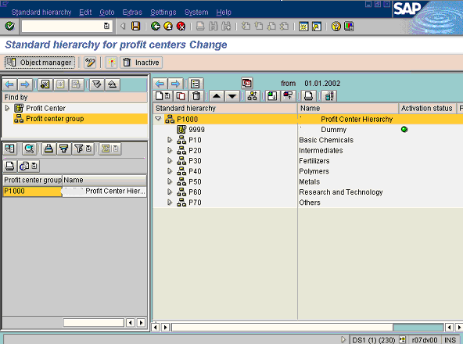

2. Click Create to add profit center groups and/or profit centers to the hierarchy.
3. Click Object manager Button .

Standard hierarchy for profit centers Change

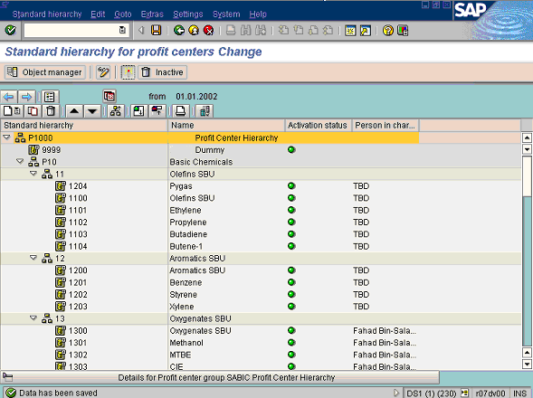

4. Click Button . To Expand Nodes
5. Select tree view node 1204 by clicking on it once.
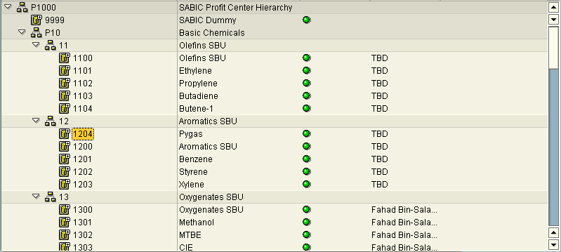

6. Select Profit center number 1204 and Drag and Drop it into Group 11

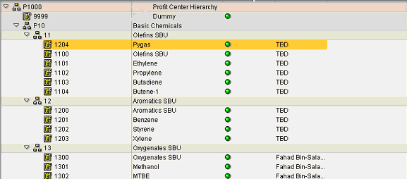

7. Click Save button.
8. The message bar displays “Data has been saved”

